Fantasy Short Story Builder Template
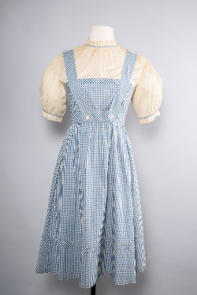
Image 1 | Image 2 | Image 3
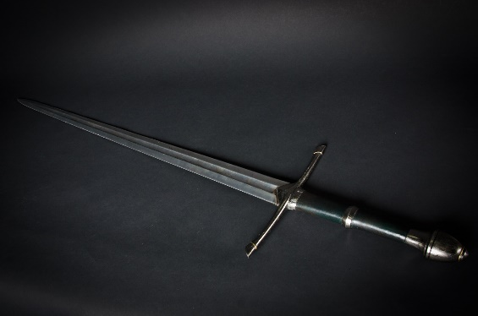 | 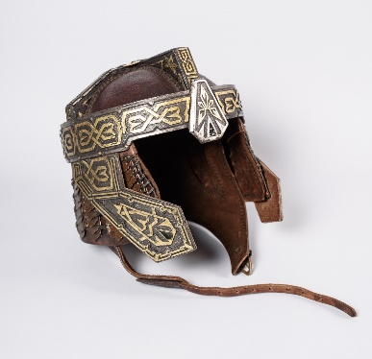 | 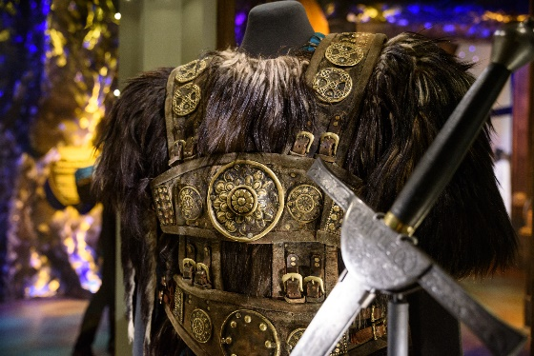
Image 4 | Image 5 | Image 6
Use the images below as inspiration from MoPOP’s exhibits and collection to write a short story following the three-act story structure. Stick with one central conflict or main problem in your story that you resolve by the end.

Act 1
Pick an image: [drop down menu of image numbers 1-6]
Write a short description of the main character of the story. HINT: Think about who your characters are before your start writing. Know their strengths and flaws.
Who is the main character?: [limit 100 words]

Write a short description of the setting of the story. HINT: Set your story somewhere specific and interesting.
What is the setting?: [limit 100 words]

In act one readers are introduced to the setting, the main character, and the start of the plot line. Don’t forget to use the image you picked as inspiration to start the story.
Write: [limit 1,500 words]

Act 2
Pick a second image: [drop down menu of image numbers 1-6]
In act 2 the plot continues. Develop the characters further and develop the conflict to the point where it looks like all hope is lost! Use the second image you picked as inspiration for act 2 of the story.
Write: [limit 1,500 words]

Act 3
Pick a last image: [drop down menu of image numbers 1—6]
In act 3 the story reaches its climax. Resolve the conflict and bring the story to its resolution. Use the third image you picked as inspiration for act 3 of the story.
Write: [limit 1,500 words]

Author Name:
Email Address:

SUBMIT

Once submitted they will receive a thank you message pop up. (automatically emailed to education-dept@mopop.org)

Image Credit
- Image 1 - Dorothy dress from The Wizard of Oz (1939). Private Collection.
- Image 2 - Staff wielded by Christopher Lee as Saruman the White in The Lord of the Rings film trilogy, 2001 – 2003. Allen Family Collection.
- Image 3 - Melting battle headdress used by the White Witch (Tilda Swinton) in The Chronicles of Narnia: The Lion, the Witch, and the Wardrobe (2005). Courtesy of D23: The Official Disney Fan Club and The Walt Disney Archives.
- Image 4 - Aragorn's Strider Sword from The Lord of the Rings (2001) and The Return of the King (2003). Allen Family Collection.
- Image 5 - Helmet worn by John Rhys-Davies as Gimli in The Lord of the Rings film trilogy, 2001 – 2003
Allen Family Collection.
- Image 6 - Tartan kilt and plaid, armor and fur poncho worn by Connor MacLeod (Christopher Lambert) in Highlander (1986). Allen Family Collection.

